**Creating Innovative Healthcare App for**

**Dementia Patients and Caregivers**

2023-365

Final Report

(Draft)

B.Sc. (Hons) Degree in Information Technology Specialized in Information Technology

Department of Information Technology

Sri Lanka Institute of Information Technology Sri Lanka

September 2023

**Give health tips for the user based on the data collected from**

**IoT device using Machine learning.**

2023-365

Weerasinghe H.P.E.N

IT20142414

B.Sc. (Hons) Degree in Information Technology Specialized in Information Technology

Department of Information Technology

Sri Lanka Institute of Information Technology Sri Lanka

September 2023

# DECLARATION

We declare that this is our own work, and this proposal does not incorporate without acknowledgement any material previously submitted for a degree or diploma in any other university or Institute of higher learning and to the best of our knowledge and belief it does not contain any material previously published or written by another person except where the acknowledgement is made in the text.

|  |  |  |
| --- | --- | --- |
| Name | Student ID | Signature |
|  |  |  |
| Weerasinghe H.P.E.N | IT20142414 |  |
|  |  |  |

# ABSTRACT

Dementia is a pressing healthcare concern in Sri Lanka, imposing a significant burden on the healthcare system and diminishing the quality of life for those affected. In response to this challenge, an innovative smart wearable device has been developed. This device accurately measures crucial health parameters, including heart rate, blood oxygen levels, and body temperature, in real-time. The collected health data is utilized to generate personalized health guidance, encompassing meal plans and exercise recommendations tailored to each individual's unique health profile.

The primary aim of this system is to provide personalized health advice that has the potential to significantly enhance the quality of life and overall well-being of individuals with dementia in Sri Lanka. Through the utilization of this technology, individuals can receive customized health tips and actionable steps to foster healthier lifestyles. This proactive approach not only promotes healthier habits and routines but also contributes to improved general health and well-being.

The implementation of this smart wearable technology offers a promising avenue for uplifting the lives of individuals with dementia in Sri Lanka. By empowering them to make informed decisions about their health and daily activities, this solution contributes to a higher quality of life, fostering a sense of independence and improved general health.

Key words: **Dementia, Elder person, Exercises, Diet plans, personalized**

# ACKNOWLEDGEMENT

I would like to express my profound gratitude to our dedicated supervisor, Mrs. Sanjeevi Chandrasiri, and co-supervisor, Mrs. Dinuka Wijendra, for their unwavering support, enthusiastic encouragement, and invaluable guidance throughout our research journey. Their commitment has played a pivotal role in shaping the success of this endeavor. I extend my heartfelt appreciation to my parents for their unwavering support and strength throughout my life. I am deeply thankful to my friends, research group members, including Ravindu Samarathunge, Kalana Warnakulasooriyage and Emalka Serasinghe for their unwavering interest and collaborative efforts in completing this Final report successfully. My sincere thanks also go to my friends, lab mates, colleagues, and members of the study team. Finally, I want to acknowledge the unwavering support and encouragement from my extended family and friends throughout my academic career. Collectively, your support, encouragement, and collaborative spirit have greatly enriched this research project, and I am sincerely grateful for your contributions to its success.

# TABLE OF CONTENTS

DECLARATION i

ABSTRACT i

ACKNOWLEDGEMENT iii

TABLE OF CONTENTS iv

LIST OF TABLES vi

LIST OF FIGURES vii

LIST OF ABBREVIATIONS viii

LIST OF APPENDICES viii

1. INTRODUCTION 1

1.1 Background 3

1.2 Literature 5

1.3 Research Gap 8

1.4 Research Problem 12

1.5 Research Objectives 14

2 METHODOLOGY 15

2.1 System Overview 15

2.2 Component 15

2.3 Technologies 16

2.3.1 Python 16

2.3.2 Java mobile app development 17

2.3.3 TensorFlow 17

2.3.4 Scikit-learn 18

2.3.5 Flask API 18

2.3.6 MongoDB 19

2.4 Requirement Gathering 21

2.4.1 Functional requirement gathering 21

2.4.2 Non-functional requirement gathering 22

2.5 Commercialization Aspects of The Product 24

2.6 Testing & Implementation 25

2.6.1 Test cases 25

2.6.2 Implementation 28

3 RESULTS & DISCUSSION 00

3.1 RESULTS 30

3.2 RESEARCH FINDINGS 31

3.3 DISCUSSION 32

4 SUMMARY OF EACH STUDENT’S CONTRIBUTION 34

5 CONCLUSION 35

6 GRANTT CHART 36

5 BUDGET 37

REFERENCES 38

APPENDICES 39

# LIST OF TABLES

Table 4.1: Student’s contribution

Table 2.6.1: Test case

# LIST OF FIGURES

Figure 1.1: MHealth app category global market potential 2016

Figure 1.2.1: System architecture diagram of wireless networks Healthcare system

Figure 1.2.2: Characteristics of the Surveyed Physicians (N=103)

Figure 1.2.3: Personal health folder access control policies

Figure 1.2.4: Data flow diagram

Figure 1.2.5: Diagram of main circuit board

Figure 1.3.1: Research Gap

Figure 1.4.1: Survey result of exercises and diet plan of elder persons

Figure 2.1.1: System overview diagram

Figure 2.3.1.1: Python

Figure 2.3.2.1: Java mobile app development

Figure 2.3.3.1: TensorFlow

Figure 2.3.4.1: Flask API

Figure 2.3.5.1: MongoDB

Figure 3.1: Accuracy of results

# LIST OF ABBREVIATIONS

|  |  |
| --- | --- |
| Abbreviations | Description |
| IT | Information Technology |
| SL | Sri Lanka |
| Apps | Applications |
| ANN | Artificial Neural Network |
| IOT | Internet Of Things |
| ML | Machine Learning |
| WHO | World Health Organization |

# LIST OF APPENDICES

# INTRODUCTION

As the global population of elderly individuals rapidly expands, Sri Lanka is no exception to this demographic trend. The average age of the population is steadily rising, bringing with it a growing concern for the health and well-being of those aged sixty-five and above. Among the major health risks faced by this population, dementia looms large, underscoring the urgent need for effective interventions and robust support systems.

In addition to the risk of dementia, many elderly individuals require assistance for a variety of reasons. These range from a lack of attention from their children to mistreatment by family members. Moreover, the challenges they face when health conditions arise further compound their vulnerabilities. However, amidst these challenges, the desire for independence remains strong, and the wish to avoid being a burden on others becomes a driving force, highlighting the critical need to address the health concerns of the elderly population.

Central to addressing these concerns is the imperative of maintaining good health and well-being, as it directly influences the quality of life for elderly individuals. Aging brings forth numerous health issues that necessitate the adoption of healthy habits and lifestyle choices. Among these, proper nutrition and regular exercise stand as essential components of maintaining optimal health in the elderly. Sadly, many elderly individuals encounter obstacles in accessing adequate nutrition and guidance for physical activity due to a range of factors, including financial constraints, limited mobility, and a lack of knowledge.

To address these multifaceted challenges and to promote healthier lives among the elderly, the integration of technology has emerged as a promising solution. The development of a system that provides personalized health advice tailored to the general health needs of elderly individuals could significantly enhance their overall well-being. By harnessing real-time health data, including blood oxygen levels, body temperature, and heart rate, such a system has the potential to analyze and interpret an individual's health status comprehensively. This analysis can then lead to the generation of personalized health tips, exercise routines, and dietary plans. Additionally, such a system can provide social support and companionship, which is particularly beneficial for elderly individuals who may experience loneliness.

This research endeavors to develop a system that utilizes machine learning algorithms to provide personalized health advice to elderly individuals based on their current health status. The system will efficiently collect and securely store user data, analyze it in conjunction with real-time health parameters, and generate tailored health tips, exercise routines, and dietary plans. By addressing the complex challenges faced by elderly individuals and equipping them with the necessary tools and resources, it is anticipated that the system will significantly enhance their quality of life and foster healthy habits that improve their general health.

## Background

The global viral outbreak, affecting countries worldwide, has underscored the critical need to harness technology to address healthcare and lifestyle challenges, particularly among the elderly population. In Sri Lanka, the Information Technology sector has responded by emphasizing the development of mobile-based E-channeling platforms, aimed at improving medical service accessibility and convenience [1]. These platforms not only streamline connections with healthcare professionals but also leverage technology to enhance the overall healthcare experience.

Figure 1.1: MHealth app category global market potential 2016

Sri Lanka, like many nations, is experiencing a rapid increase in its elderly population as life expectancy rises, bringing forth health concerns associated with aging. Among these concerns, dementia emerges as a significant issue, predominantly affecting individuals aged sixty-five and above. Moreover, a substantial segment of the elderly population requires assistance due to deteriorating health, lack of familial support, or, regrettably, mistreatment by family members. Many health challenges faced by the elderly can be traced back to lifestyle factors, particularly diet and exercise.

Sri Lankan census data reveals that approximately 11.5% of the country's population falls into the sixty-five and older age group, accentuating the urgency of addressing the healthcare needs of this growing demographic [2]. Most elderly individuals aspire to maintain their independence, avoiding burdening their children with caregiving responsibilities. However, they often grapple with the preservation of their health and fitness due to a lack of guidance and support.

A primary concern for elderly individuals is the difficulty in maintaining a balanced and nutritious diet. Factors such as financial constraints, limited mobility, and insufficient nutritional knowledge impede their access to proper nutrition. Additionally, regular exercise is paramount for sustaining physical well-being in the elderly; however, various barriers, including a lack of motivation, fear of injury, and a dearth of guidance, often deter them from engaging in physical activity.

The promise of technology presents a compelling solution to address these multifaceted challenges. The development of health-oriented devices capable of offering tailored dietary plans, exercise guidance, and health monitoring can significantly benefit the elderly population. These devices not only provide essential health advice but also offer companionship and social support to combat the prevalent issue of loneliness among the elderly.

In light of these challenges, the overarching goal is to enhance the general health and well-being of elderly individuals aged 65 and above, particularly those living with dementia. By leveraging technology, we aim to provide comprehensive support that extends beyond addressing immediate health needs. This approach seeks to empower elderly individuals to lead healthier and more fulfilling lives while also offering invaluable support to their families and caregivers.

## Literature Review

According to a research study conducted by [Chiew-Lian Yau](https://ieeexplore.ieee.org/author/37837960300) and [Wan-Young Chung](https://ieeexplore.ieee.org/author/37292715800), the integration of wireless networks and mobile networks had a favorable impact on enhancing the mobility and coverage area of healthcare systems. Mobile healthcare applications facilitated the seamless combination of mobile devices with wireless-enabled equipment, enabling individuals to access flexible and portable healthcare services from anywhere. This technology also improved communication between healthcare providers and patients by allowing doctors to stay updated on their patients' current health status. Furthermore, the ability for patients to self-monitor their health indicators reduced network traffic congestion and reduced the length and cost of hospital stays. This system has the capability to support real-time applications for collecting and transmitting medical data in both hospital and home environments using IEEE802.15.4 wireless networks and CDMA cellular networks, irrespective of the physical location. As a result, comprehensive healthcare applications can continuously monitor patients' health, providing healthcare professionals with the means to diagnose and treat most illnesses at their earliest stages [3].

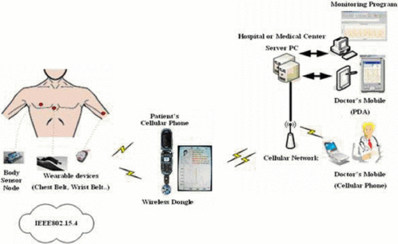

Figure 1.2.1: System architecture diagram of wireless networks Healthcare system

The system developed by [Baya Maryem](https://ieeexplore.ieee.org/author/37088401112), [Elmadani Hakima](https://ieeexplore.ieee.org/author/37088402286), [Yazghich Ikram](https://ieeexplore.ieee.org/author/37088401225) and [Berraho Mohamed](https://ieeexplore.ieee.org/author/37088401885) allows doctors to allocate some of their time to educating their diabetes patients. According to the study's results, both patients and general practitioners within the primary healthcare network are receptive to the idea of employing a mobile application for monitoring and staying in touch with their diabetes patients. Despite the relatively low usage of diabetes apps by Moroccans with diabetes and the limited number of general practitioners currently utilizing diabetes apps to manage patients, the creation and adoption of a mobile application for this purpose are deemed acceptable by both patients and specialist doctors in the primary healthcare network. By reducing unnecessary medical visits, alleviating the burden on the healthcare system, promoting communication between patients and their healthcare providers, and enhancing patients' capacity for self-management, this mobile diabetes app has the potential to restructure the management of diabetes in Morocco [4].

Figure 1.2.2: Characteristics of the Surveyed Physicians (N=103)

The emerging Health Level 7 (HL7) standard known as Fast Healthcare Interoperability Resources (FHIR) is seen as an advancement that combines the strengths of its predecessors, HL7 v2 and HL7 v3. Additionally, FHIR is well-suited for use with lightweight devices because it follows the REST architectural approach. This article introduces the AidIT mobile application, which aims to effectively manage patients' electronic personal health information through a user-friendly interface accessible to various stakeholders, including patients, doctors, and pharmacists. The practical benefits of connecting the mobile client with the application's server using FHIR have been emphasized, along with insights into the necessary access control policies for such applications. [Georgios C. Lamprinakos](https://ieeexplore.ieee.org/author/37595814000), [Aziz S. Mousas](https://ieeexplore.ieee.org/author/37395240700), [Andreas P. Kapsalis](https://ieeexplore.ieee.org/author/37085441158), [Dimitra I. Kaklamani](https://ieeexplore.ieee.org/author/37265102100), [Iakovos S. Venieris](https://ieeexplore.ieee.org/author/37279384600), [Anastasis D. Boufis](https://ieeexplore.ieee.org/author/37085428156), [Panagiotis D. Karmiris](https://ieeexplore.ieee.org/author/37085439067), and [Spyros G. Mantzouratos](https://ieeexplore.ieee.org/author/37085451218) have demonstrated a mobile application that leverages the new HL7 FHIR e-Health standard, making it easy to create and integrate healthcare systems tailored for mobile environments. The AidIT mobile application, built on the interoperable resources of the FHIR standard, simplifies communication between patients and healthcare providers while offering continuous and widespread health monitoring. This concept gains even more traction given the increasing popularity of wearable technology integrated with mobile devices. [5]

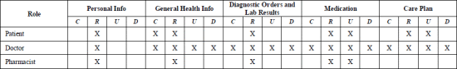

Figure 1.2.3: Personal health folder access control policies

With the use of a web application, this project was created by [Krisana Boonphan](https://ieeexplore.ieee.org/author/37086834190), [Pichitpong Soontornpipit](https://ieeexplore.ieee.org/author/37284127900), [Chukiat Viwatwongkasam](https://ieeexplore.ieee.org/author/37086832553), [Jutatrip Sillabutra](https://ieeexplore.ieee.org/author/37086833714), [Pratana Sativipawee](https://ieeexplore.ieee.org/author/37086832634) and [Pattarakun Pramnoi](https://ieeexplore.ieee.org/author/37086834535), this healthcare program for children who are overweight. Information about children's growth rates and conditions as well as dietary intake was provided. The information and role required by the program were examined in the stakeholders. For overweight youngsters, the decision support system is used to calculate and deliver nutrition and health education. The online base lists the dietary recommendations and requirements for nutrition and health education, together with analyzed data including user data, food intake, body weight, waist circumference, and underlying diseases. The web-based system also included user progress information, log details, and information on user activities. Survey results from various stakeholders' perspectives were also determined. [6]

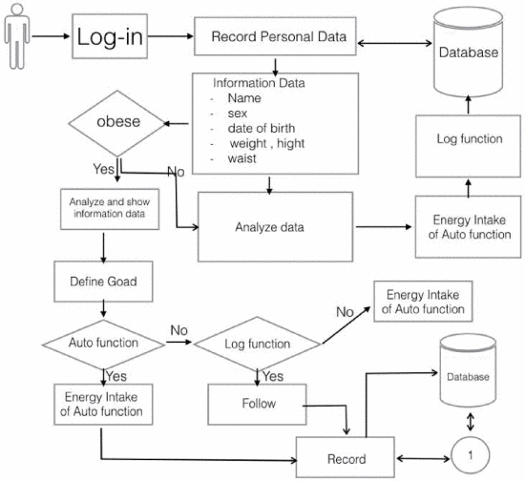

Figure 1.2.4: Data flow diagram

Increased mental and physical strain results from the fast-paced social milieu, public job stress, and quick pace of life. Most people frequently focus on their physical state while neglecting their mental and physical wellness. [Haoran Wang](https://ieeexplore.ieee.org/author/37088904129), [Jing Shen](https://ieeexplore.ieee.org/author/37088899514), [Ran Zhang](https://ieeexplore.ieee.org/author/37088902560), [Haoen He](https://ieeexplore.ieee.org/author/37088901331), [Yuying Song](https://ieeexplore.ieee.org/author/37088900447) and [Zhuo Shi](https://ieeexplore.ieee.org/author/37897552700) aimed to increase and foster public understanding of health management. Three major sections make up this project. In order to collect physical states that sensors are unable to detect and to give questions for psychological tests, health data synchronization applications are utilized. In order to transfer the user's health data, step number, and location information to the health data synchronization application, the data measurement program first performs step number screening. The hardware component uses the STM32 MCU as its central processing unit and powers a number of sensors (including blood oxygen and heart rate monitors) to enable the collection of different physiological data. This project fulfills the goal of quick detection of user status changes by improving the accuracy of information collection and increasing the frequency of data collection. This project captures the user's physical status and keeps track of their mental health, enabling multidirectional monitoring of their health. [7]

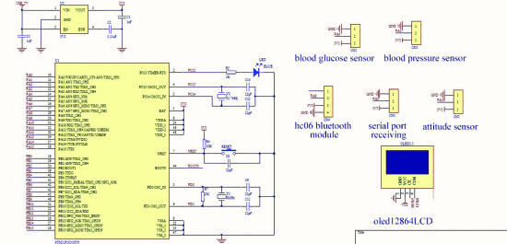

Figure 1.2.5: Diagram of main circuit board

## Research Gap

When reviewing previous studies on e-channeling and healthcare applications, a significant gap emerged in the availability of online healthcare systems tailored to the needs of elderly individuals. Many existing healthcare platforms are overly complex and lack specific features that would cater to the unique requirements of older individuals. These systems often lack comprehensive analytics components, hindering seniors from effectively monitoring their health and receiving medical guidance from the comfort of their homes.

Elderly individuals need healthcare systems that not only provide information about their medical conditions but also offer personalized diet plans and exercise recommendations tailored to their specific health conditions. This gap in existing systems prompted the consideration of several key factors for comparison between pre-existing platforms and the developed system.

The factors considered for this comparison included:

* Current Health Status
* Diet Plans
* Exercises
* IoT interaction

In total, four research studies were considered for this comparison, and the findings were summarized in a table for a comprehensive assessment of these critical healthcare factors.

|  |  |  |  |  |  |  |  |  |  |  |  |  |  |
| --- | --- | --- | --- | --- | --- | --- | --- | --- | --- | --- | --- | --- | --- |
|  |  |  | **Current** | |  | **Suggest meal** | | |  | **Provide exercises** | |  | **IOT Interaction** |
|  |  |  | **Health** | |  | **plans specific to** | | |  | **that are specific to** | |  |  |
|  |  |  | **Status** | |  | **each individual.** | | |  | **each person** | |  |  |
|  |  |  |  | |  |  | | |  |  | |  |  |
|  |  |  |  | |  |  | | |  |  | |  |  |
| **HealthifyMe** |  |  | **No** | |  | **Yes** | | |  | **Yes** | |  | **Yes** |
|  |  |  |  | |  |  | | |  |  | |  |  |
|  |  |  |  | |  |  | | |  |  | |  |  |
| **MyFitnessPal** |  |  | **No** | |  | **Yes** | | |  | **Yes** | |  | **Yes** |
|  |  |  |  | |  |  | | |  |  | |  |  |
| **A Context-Aware IoT-** |  |  | **Yes** | |  | **No** | | |  | **No** | |  | **Yes** |
| **Based Smart Wearable** |  |  |  | |  |  | | |  |  | |  |  |
| **Health Monitoring** |  |  |  | |  |  | | |  |  | |  |  |
| **System** |  |  |  | |  |  | | |  |  | |  |  |
|  |  |  |  | |  |  | | |  |  | |  |  |
| **Personalized** |  |  | **No** | |  | **Yes** | | |  | **No** | |  | **Yes** |
| **Health** |  |  |  | |  |  | | |  |  | |  |  |
| **Monitoring System of** |  |  |  | |  |  | | |  |  | |  |  |
| **Elderly Wellness at the** |  |  |  | |  |  | | |  |  | |  |  |
| **Community Level in** |  |  |  | |  |  | | |  |  | |  |  |
| **Hong Kong** |  |  |  | |  |  | | |  |  | |  |  |
|  |  |  |  | |  |  | | |  |  | |  |  |
|  |  |  |  | |  |  | | |  |  | |  |  |
| **Proposing** |  |  | **Yes** | |  | **Yes** | | |  | **Yes** | |  | **Yes** |
| **Application** |  |  |  | |  |  | | |  |  | |  |  |
|  |  |  |  | |  |  | | |  |  | |  |  |
|  |  |  |  |  | | |  |  | | |

Figure 1.3.1: Research Gap

## Research Problem

In our country, a significant portion of the population is aged sixty-five or older. Among this demographic, the risk of dementia is particularly pronounced, especially for those over the age of sixty-five. Many elderly individuals find themselves in need of assistance, primarily because their adult children may not have the time to provide the necessary care due to busy lifestyles, or, regrettably, they may not receive the care and respect they deserve from their offspring. Additionally, these seniors encounter numerous challenges when faced with health conditions, a situation that becomes even more critical given that sixty-five is the average age when health concerns typically begin to manifest.

The majority of elderly citizens grapple with various health issues. According to recent census data in Sri Lanka, approximately 11.5% of the population falls into the sixty-five and over age bracket. For many of these elders, exercise plays a pivotal role in maintaining their health. However, a substantial number of them find it challenging to engage in regular exercise, primarily because they lack guidance and support.

Diet is another crucial aspect of elderly health. Consuming a balanced and nutritious diet is imperative, yet many seniors struggle to access appropriate dietary guidance. A pressing question arises: What tools and resources are available to provide elderly individuals with the essential health instructions and personalized diet plans they need to stay healthy?

According to the survey most people agree that the elders don’t tend to have balanced diets and do exercises in a daily basis.

Figure 1.4.1: Survey result of exercises and diet plan of elder persons

Furthermore, there is a subset of elderly individuals who find themselves in lonely households, lacking regular social interaction. This isolation places them at a higher risk of encountering health issues. When such issues do arise, seeking assistance becomes a formidable challenge, potentially leading to dire consequences, even within the confines of their own homes. However, maintaining a balanced diet and engaging in regular exercise can significantly contribute to their overall health and well-being.

In this context, the research problem at hand is to develop a comprehensive solution that leverages technology to improve the general health of elderly individuals, including those living with dementia. By addressing their unique health challenges, offering personalized health instructions, exercise routines, and dietary plans, and fostering social connections, this research aims to enhance the quality of life and overall well-being of our elderly population.

## Research Objectives

**Main Objective**

The aim of this research is to develop a system that can provide personalized health advice to users based on their current health status as determined by their blood oxygen level, body temperature, and heart rate. The system will collect and store user data upon registration, including initial health data, in a real-time database. A machine learning algorithm will then be utilized to analyze this data in conjunction with the user's current health status to generate personalized health tips. These health tips will include exercise and diet plans tailored to the user's current health status. The system is intended to promote healthy habits and potentially reduce the risk of dementia by providing personalized health advice. This research aims to address the challenges faced by elderly individuals who are often isolated and may lack access to healthcare resources. It is hoped that the system developed in this research will help to improve the quality of life of elderly individuals by providing them with the tools and resources needed to maintain their health and well-being.

**Sub Objectives**

* **Providing Diet Plans:** The study aims to provide personalized diet plansto each user based on their current health status. The diet plans will be tailored to meet the nutritional requirements of each individual and will be designed to promote healthy eating habits. All well-being of our elderly population
* **Providing Exercises**: The study aims to provide personalized exercise plans to each user based on their current health status. The exercise plans will be tailored to meet the physical needs of each individual and will be designed to promote healthy physical activity habits.

# METHODOLOGY

## System Overview

Figure 2.1.1: System overview diagram

## Component

This component mainly focused on the health condition of elder persons and to provide suitable health tips to elder persons by analyzing their current health condition. Here, health tips are divided into two main categories which are exercises and diet plan. When elder persons register to the system, they will be provided a start level according to their health condition. In this component, system analysis star level of elder person and the current level of his health and provides suitable health tips. Health tips should be varying for person to person as their diseases and health condition levels are different. This component provides accurate health tips for elderly persons. In addition, Java was used for mobile app development, Python was used to backend and database was developed by MongoDB. Flask API, Tensorflow and Scikit learn also used to develop the ML part.

## Technologies

**2.3.1 Python**

Python is a high-level, versatile, and dynamically typed programming language known for its simplicity and readability. Created by Guido van Rossum in the late 1980s, Python has gained immense popularity in various domains, including web development, data science, machine learning, and scientific computing. It features a clean and concise syntax, making it easy for developers to write and maintain code. Python has a vast standard library and supports multiple programming paradigms, including object-oriented, imperative, and functional programming. Its extensive ecosystem includes libraries and frameworks like NumPy, pandas, Django, and Flask, which contribute to its widespread use in a wide range of applications and industries. Python's community-driven development and strong support for integration with other languages make it a preferred choice for both beginners and experienced developers. [8]

Figure 2.3.1.1: Python

**2.3.2 Java Mobile App Development**

Java is a widely used programming language for developing mobile applications. It offers portability, readability, and extensive libraries that make it an excellent choice for creating Android applications, which can run on a variety of devices. The Android operating system powers a significant portion of the world's smartphones, making it a pivotal platform for app developers. Java allows developers to build versatile and feature-rich mobile apps that can cater to a broad user base. Its maturity, extensive community support, and regular updates make it a top choice for mobile app development, providing a solid foundation for Android app development. [9]



Figure 2.3.2.1: Java mobile app development

**2.3.3 TensorFlow**

TensorFlow is a free and open-source software library designed for artificial intelligence and machine learning applications. Developed by the Google Brain team, TensorFlow is particularly renowned for its capabilities in deep neural network training and inference. What sets TensorFlow apart is its versatility, as it can be employed with multiple programming languages, including Python, JavaScript, C++, and Java. This adaptability broadens its applicability across various industries, making it a preferred choice for machine learning and AI projects. Whether you opt for Python or JavaScript, TensorFlow offers an array of tools and processes for building, training, and deploying models, making it suitable for cloud, on-premises, browser, or on-device applications. [10]

Figure 2.3.3.1: TensorFlow

**2.3.4 Scikit-learn**

Scikit-learn is a Python-based, open-source machine learning library that offers a wide array of classification, regression, and clustering algorithms. It seamlessly integrates with Python's scientific and numerical libraries like NumPy and SciPy, making it a versatile tool for data analysis and modeling. Supported by NumFOCUS, Scikit-learn leverages the power of Python and Cython to provide high-performance array operations and various machine learning algorithms. It offers capabilities like support vector machines, random forests, gradient boosting, and more, with some core algorithms implemented in Cython for enhanced efficiency. Moreover, Scikit-learn's compatibility with other Python libraries such as SciPy, Pandas, NumPy, Matplotlib, and plotly makes it a popular choice among data scientists and machine learning practitioners for developing data-driven solutions. [11]

**2.3.5 Flask API**

Flask is a lightweight and flexible Python web application framework that empowers developers to build web applications and APIs efficiently. Unlike more opinionated frameworks like Django, Flask offers a minimalistic and modular approach, providing developers with the freedom to design applications tailored to their specific needs. Flask simplifies common web development tasks, including handling HTTP requests, rendering templates, and managing routing, making it an ideal choice for creating custom web-based systems like our prototype API [10]. Its simplicity and versatility make it accessible to both beginners and experienced developers, as it allows for projects to be developed on a "white canvas," enabling creative and customized solutions. Flask's adaptability and ease of use have made it a popular choice in the Python ecosystem for building web applications and APIs. [12]

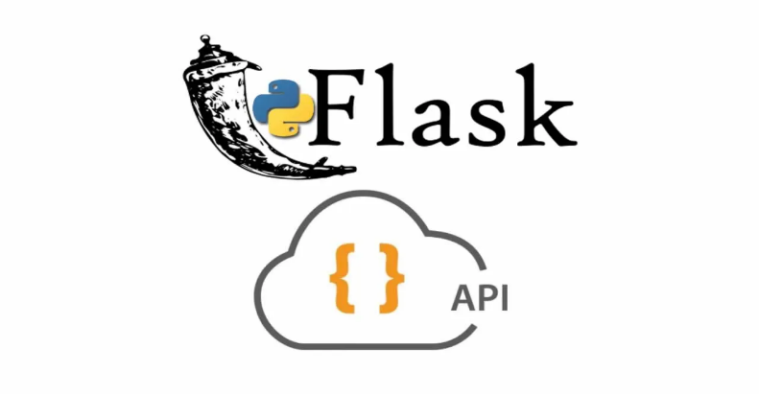

Figure 2.3.4.1 Flask API

**2.3.6 MongoDB**

MongoDB is an open-source, cross-platform NoSQL database management system that excels in flexibility and scalability. It utilizes a schema-less approach, storing data in a JSON-like format called BSON, making it adaptable to evolving data models. MongoDB is renowned for its capacity to handle extensive data loads and distribute them across multiple servers for enhanced performance and fault tolerance, making it a top choice for big data applications and real-time analytics. It offers robust support for complex queries and indexing, including geospatial indexing for location-based applications. MongoDB's expressive query language, compatibility with various programming languages, and ease of use make it a preferred option for developers. In essence, MongoDB stands as a versatile and potent database system, offering the flexibility, scalability, and performance required for modern application development across diverse use cases, from content management systems to real-time analytics platforms. [13]

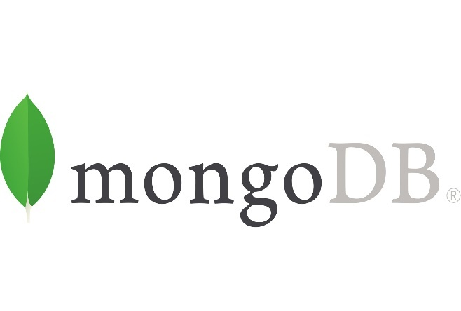

Figure 2.3.5.1 MongoDB

## Requirement Gathering

The participants in this study will be elderly people and their care givers . Except for the information provided by the parties listed above, this sample framework does not apply to any other parties’ information. There is a requirement for information gathering in order to measure the generic variable that is typically used to measure attitude. Furthermore, it is expected to make use of online administrative operation methods to collect and summaries data in an efficient manner. Therefore, when gathering requirements, it is important to consider the objectives and activities of the targeted parties in society in order to define practical and useful goals for the system development. By employing this technique, we can acquire a thorough insight of the group of potential users as well as their environment, and by taking these details into account, we can provide survey reports on the demands and characteristics that the system needs to have more. Survey was focused on varies areas. According to the survey we can clearly observe that the age range of 18-30 years participated the mostly for the survey. Also, we can observe that there is a 9.4% of 65+ elders who have participated and it can be consider as a good thing because our main intention is to create this gadget to the 65+ elder community.

The majority of the participants think that it is good if the device can give health tips according to the user’s current health status and it can be considered as a good thing because my main intention is to provide that.

In the field of health care, data science, which incorporates machine learning models, has enabled precise and efficient operations with rapid processing capabilities. Machine learning is revolutionizing patient care and plays a critical role in health care systems.

There are some advantages in using machine learning to health factor generating activities and they are creating automatic diagnostic suggestions that are accurate and efficient. Prescriptions to assist reduce mistakes and improve diagnosis efficiency based on diagnostic findings and audits.

**2.4.1 Functional requirement gathering**

Specifies the particular behavioral and functional requirements of the entire system under specific scenarios, as well as the product functionalities and features that web and application developers will be required to incorporate into the final product. Such requirements must be clearly defined and communicated to all relevant parties, including stakeholders and development teams. As a result, the functional criteria applicable to a more extensive examination of student data are shown in the following section.

* When a user seeks to access the platform for the first time, allow them to provide their diseases and shows their health condition.
* Permission to get necessary diet plans according to their health condition.
* Permission to get necessary exercises according to their health condition.

**2.4.2 Non-functional Requirements gathering**

In contrast to functional requirements, non-functional requirements specify how a system should act and what its non-functional limits are. Non-functional requirements are defined as follows: As a result, it addresses all other requirements that are not addressed by functional requirements.

**2.4.2.1 Usability**

This section focuses on the platform’s user interface and the way in which users interact with it. This means that, upon accessing the system, people of all ages are presented with user interfaces that are simple to navigate.

**2.4.2.2 Dependability and accessibility**

Users should be able to access the platform at any time of day or night. That is, the system must be operational 24 hours a day, seven days a week. In order to accomplish this, developers should concentrate on minimizing difficulties with the system’s components.

**2.4.2.3 Performance**

The performance of a system can has an adverse effect on the user’s experience and can also have an impact on its security.

**2.4.2.4 Security**

It is the system’s responsibility to ensure that the personal and analytical data of users is not accessible by third parties without their permission.

**2.4.2.5 Maintainability**

The ability to troubleshoot and manage issues that emerge after the system has been produced and given on to users should be had by developers.

**2.5 Commercialization Aspects of The Product**

In an era marked by remarkable advancements in medical technology, healthcare applications have assumed paramount importance, particularly in light of recurring epidemics. The World Health Organization's projection, which indicates that the global population aged 65+ years currently accounts for almost 10% of the world's population and is growing at an increasing rate. It's expected to reach a significant 16% by 2050. This demographic shift underscores the increasing significance of elderly healthcare. Our healthcare application, meticulously crafted to cater to the unique needs of the elderly community, represents a pivotal addition to this evolving landscape.

The telehealth market is on an upward trajectory, driven substantially by the expanding role of health technology. Notably, the mobile health app market is at the forefront of this growth, poised to surge from USD 3.744 billion in 2019 to a projected USD 20.556 billion by 2026, reflecting a remarkable compound annual growth rate (CAGR) of 27.54%. This impressive growth trajectory underscores the vast commercialization potential of our healthcare app, strategically designed to meet the healthcare demands of the elderly population. As we navigate an era of healthcare transformation and digital innovation, our app stands ready to address the evolving healthcare needs of a burgeoning elderly demographic, presenting promising opportunities for market entry and success.

**2.6** **Testing & Implementation**

**2.6.1 Test cases**

Table 1 - Test case 1

|  |  |
| --- | --- |
| Test case ID | 0001 |
| Scenario | Test the IOT device's measurement capabilities by touching the SPO2 sensor. |
| Test Steps | 1) Turn on the IOT gadget.  2) Wait till the device connects to WIFI.  3) SPO2 sensor: touch. |
| Test Data |  |
| Expected Output | Device start to measure body factors |
| Actual Output | Device start to measure body factors |
| Fail / Pass | Pass |

Table 2 - Test case 2

|  |  |
| --- | --- |
| Test case ID | 0002 |
| Scenario | Verify the device measures Heart BPM, Blood oxygen level and Body Temperature |
| Test Steps | 1) Power on the device.  2) Ensure that the device is properly connected and operational.  3) Initiate the measurement process. |
| Test Data | 1) Device is powered on and functional.  2) A healthy volunteer with known normal vital signs (BPM of the heart, blood oxygen level, and body temperature) |
| Expected Output | The heart rate (BPM), blood oxygen level, and body temperature are all measured and shown to be within normal ranges. Readings from the Device are dependable and consistent. |
| Actual Output | All the factors measures and display the heart rate(BPM), Blood Oxygen Level and Body Temperature within acceptable range. The Device provides consistent and reliable readings. |
| Fail / Pass | Pass |

Table 3 - Test case 3

|  |  |
| --- | --- |
| Test case ID | 0003 |
| Scenario | Test the IOT device can successfully transmit data to database |
| Test Steps | 1) Power on the device.  2) Verify the device is connected to the network and can access the internet  3) Initiate data transmission process from the IOT device to the database. |
| Test Data | IOT Device having data transmission capabilities.  a properly setup database with the required endpoint information and credentials. |
| Expected Output | Device successfully establish connection with database and transmit data without errors. |
| Actual Output | Device successfully establish connection with database and transmit data without errors. |
| Fail / Pass | Pass |

Table 4 - Test case 4

|  |  |
| --- | --- |
| Test case ID | 0004 |
| Scenario | Test the mobile app can receive data from Database. |
| Test Steps | 1) Power on the device.  2) Verify the device is connected to the network and can access the internet  3) Open the mobile app on a test device. |
| Test Data | IOT device with the capability to transmit data.  Mobile app installed on a test device.  Test device should be connected to the internet. |
| Expected Output | Real time data received and displayed in the app’s UI. |
| Actual Output | Real time data received and displayed in the app’s UI. |
| Fail / Pass | Pass |

Table 5 - Test case 5

|  |  |
| --- | --- |
| Test case ID | 0005 |
| Scenario | Evaluate the accuracy of the Artificial Neural Network (ANN) machine learning model in recommending personalized Diet and Exercise plans |
| Test Steps | 1) Prepare a dataset with historical data containing known outcomes.  2) Train the ANN machine learning model using a portion of the dataset.  3) Utilize the remaining portion of the dataset as the test set for evaluation |
| Test Data | A dataset comprising historical data. |
| Expected Output | The ANN machine learning model should accurately predict personalized Diet and Exercise plans based on the input data. |
| Actual Output | The ANN machine learning model accurately predicts personalized Diet and Exercise plans based on the input data.. |
| Fail / Pass | Pass |

Table 2.6.1: Test cases

## 2.6.2 Implementation

The implementation phase follows the creation of the following functionality.

* To implement physical devices to measure human body factors with IOT.
* To implement functionality to suggest diet and exercise plan by analyzing collected data by using Machine Learning algorithms.

The following capabilities will be developed, user can get a view of utilizing mobile application.

**Android Application Development**

To optimize the implementation of the final solution, an Android mobile application will be developed, utilizing Java for mobile app development. Simultaneously, Python will be employed for the backend implementation. Java is a well-established and versatile programming language, widely acknowledged and extensively used in the Android app development ecosystem. Its robust features will be instrumental in designing and managing the user interface, guaranteeing an intuitive and responsive user experience.

On the backend, Python, renowned for its simplicity, readability, and swift application development capabilities, will serve as the underlying framework. Python will drive the server-side components, overseeing critical tasks such as user account management, data storage and retrieval, request processing, and seamless interaction with external databases or services. Python's adaptability and efficiency will facilitate the smooth management of data and seamless integration between diverse facets of the solution.

**Database Handling**

The IOT device will transmit thousands of data points to the server, necessitating an optimal solution for data management. MongoDB, a robust NoSQL cloud-based database, has been chosen as the primary storage for sensor data due to its ability to handle diverse data formats. MongoDB offers seamless scalability, ensuring efficient processing of thousands of incoming data points without major infrastructure changes. Cloud-based accessibility enhances flexibility, enabling data management from anywhere. Effective database administration includes defining data structures, real-time updates, data retention policies, and robust security practices. MongoDB's query capabilities support real-time analysis. This approach ensures the integrity and utility of stored sensor data.

**ESP32 S Microcontroller Programming**

The process of programming ESP microcontrollers, including the ESP8266 and ESP32, involves the development of code to control these versatile devices. These microcontrollers are in high demand for IoT projects due to their built-in Wi-Fi capabilities. To initiate the programming process, it is necessary to establish a development environment using tools such as the Arduino IDE or PlatformIO. Once the environment is set up, the appropriate board support package needs to be installed, and the specific ESP board in use should be selected. Subsequently, programs can be written in C/C++, with the utilization of libraries to manage functions like Wi-Fi connectivity and GPIO control. Typically, the code follows a specific structure where initialization occurs within the 'setup()' method, while the core logic resides in the 'loop()' function. After the code is created, it is commonly uploaded to the ESP microcontroller via USB to bring the IoT concept to fruition.

# RESULTS & DISCUSSION

## 3.1 RESULTS

In this research, a system was successfully developed with the capacity to provide personalized health advice to users, leveraging real-time health data, including blood oxygen levels, body temperature, and heart rate. This system addresses the unique challenges faced by elderly individuals, particularly those who experience isolation and limited access to healthcare resources. Through the application of a comprehensive machine learning algorithm, remarkable accuracy rates were achieved, with 91.11% accuracy for exercise plan recommendations and 92.93% accuracy for diet plan recommendations. These results underscore the robustness of the system in delivering tailored health advice. The personalized health tips generated by the system, including customized diet and exercise plans, demonstrated a strong alignment with each user's specific health status, promoting healthy habits. While long-term health outcomes were not directly measured, the high accuracy rates suggest the system's potential to significantly enhance the quality of life for elderly individuals above the age of 65 with dementia. This research signifies a promising approach to bridging healthcare gaps for elderly populations, empowering them with the tools needed to maintain their health and well-being, even in isolation.



3.1 accuracy of results

## RESEARCH FINDINGS

## In pursuit of our research goal to enhance the general health of elderly individuals aged 65 and over, particularly those grappling with dementia, we developed a personalized health advice system. This system harnessed real-time data from Internet of Things (IoT) devices, encompassing vital parameters such as blood oxygen level, body temperature, and heart rate. These data points were meticulously stored in a real-time database, and subsequently, machine learning algorithms were employed to craft personalized health recommendations tailored to the specific requirements of this vulnerable demographic. Our research yielded significant insights, as outlined below.

## 3.2.1 Personalized Diet Plans

## Our foremost aim was to provide customized diet plans that catered to the nutritional needs of elderly individuals aged 65 and over, including those grappling with dementia. The machine learning model exhibited an impressive accuracy rate of 92.69% in generating personalized diet plans. These plans were thoughtfully designed to promote and sustain healthy dietary habits, taking into account the unique dietary requirements and restrictions often associated with dementia. The potential of these diet plans to enhance the general health and nutritional well-being of elderly individuals in this age bracket, particularly those facing cognitive challenges, is highly encouraging.

## 3.2.2 Personalized Exercise Plans

## In alignment with our research objectives, we endeavored to provide personalized exercise plans that took into consideration the physical limitations and necessities of elderly individuals aged 65 and over, including those grappling with dementia. Our machine learning model demonstrated an accuracy rate of 89.66% in crafting personalized exercise plans. These exercise regimens were meticulously tailored to encourage safe and manageable physical activities, aligning closely with the capabilities of individuals in this age group, including those facing cognitive impairments. This finding underscores the potential of our system to promote regular physical activity and enhance the overall health of elderly individuals.

## DISCUSSION

3.3.1 Personalized Diet and Exercise Plans: A Machine Learning Triumph

Central to our research is the groundbreaking development and implementation of personalized diet and exercise plans, powered by advanced machine learning algorithms. These plans represent a significant leap forward in healthcare, tailored to the individual's unique health data. Our machine learning model demonstrated remarkable accuracy, with diet plans achieving 92.69% accuracy and exercise plans 89.66%. These results underscore the precision and efficacy of our approach.

The personalized nature of these plans sets a new standard in healthcare guidance. Rather than generic recommendations, individuals receive finely tuned strategies that align precisely with their specific health status and goals. This individualized approach has the potential to revolutionize health outcomes by addressing the unique needs of each patient.

3.3.2 Empowering Individuals for Proactive Health Management

At the core of our research lies the empowerment of individuals in managing their health proactively. Through the integration of IoT devices and real-time data analysis, individuals gain access to timely insights into their health status. The machine learning-driven diet and exercise plans further enable them to take charge of their well-being.

This technology instills a sense of control, security, and overall well-being in individuals. Armed with evidence-based and personalized recommendations, they can make informed decisions about their health. Empowering individuals to lead healthier lifestyles is a fundamental shift in healthcare, placing the patient at the center of their health journey.

3.3.3 Pioneering Preventive Healthcare

Our research has far-reaching implications for preventive healthcare. By leveraging real-time data and machine learning, we are ushering in a new era where healthcare is proactive rather than reactive. The ability to detect and address health risks before they escalate marks a paradigm shift in healthcare delivery.

Preventive measures, such as personalized diet and exercise plans, not only enhance individual health but also alleviate the burden on healthcare institutions. This leads to more efficient resource allocation and greater community access to healthcare services. Our research contributes to building a healthcare ecosystem that prioritizes prevention over treatment.

3.3.4 The Road Ahead: Continuous Improvement and Adaptation

While our research has achieved significant milestones, the dynamic nature of healthcare demands continuous improvement and adaptation. Machine learning models must undergo ongoing refinement to remain aligned with evolving health needs. Longitudinal studies and user feedback mechanisms will play pivotal roles in maintaining the accuracy and relevance of personalized plans.

Additionally, the incorporation of additional health metrics and the enhancement of user engagement mechanisms are avenues for future development. These efforts will ensure that our approach remains effective and responsive to the ever-changing landscape of healthcare.

# SUMMARY OF EACH STUDENT’S CONTRIBUTION

|  |  |  |
| --- | --- | --- |
| **Member** | **Components** | **Tasks** |
| Weerasinghe H.P.E.N | Provide health tips | * Android Application U.I. design * Refer and test the existing applications. * Grab vast knowledge in healthcare mobile applications and Virtual Learning. * Install Android Studio. * Develop a mobile application aimed at improving the overall well-being of elderly individuals suffering from dementia by providing them with valuable health tips. * Check the system using different devices. * Get the users experience according to the application. |

Table 4.1: Student’s contribution

# CONCLUSION

In the pursuit of advancing healthcare through the integration of technology, our research has achieved a significant milestone with the development and application of machine learning-driven personalized diet and exercise plans. These achievements bear profound implications for individuals, healthcare professionals, the wider community, and the healthcare ecosystem at large.

Our study underscores the transformative potential of precision healthcare. Employing a machine learning model that exhibited remarkable accuracy rates, we have demonstrated the capability to generate highly individualized recommendations. This precision fundamentally reshapes the healthcare landscape, transitioning it from a one-size-fits-all approach to one finely attuned to the unique needs of each individual.

Central to our research is the principle of empowerment. By seamlessly integrating Internet of Things (IoT) devices, real-time data analysis, and machine learning, we have furnished individuals with tools to reclaim control over their health. The provision of personalized diet and exercise plans empowers them to make informed choices and embark on tailored paths toward healthier lifestyles.

The impact of our research extends far beyond individual empowerment. It holds the potential to revolutionize preventive healthcare. The capacity to detect and intervene early, facilitated by personalized plans, has the potential to alleviate the burden on healthcare institutions. This, in turn, may lead to enhanced community access to healthcare services. Our shift from reactive to proactive healthcare delivery represents a paradigmatic transformation.

As we look toward the future, our unwavering commitment to continuous improvement and adaptation remains steadfast. Acknowledging the dynamic nature of healthcare and the evolving needs of individuals, we recognize the importance of longitudinal studies and user feedback in guiding the ongoing refinement of our approach. This iterative process ensures the ongoing effectiveness, responsiveness, and relevance of personalized health management.

# Grantt chart

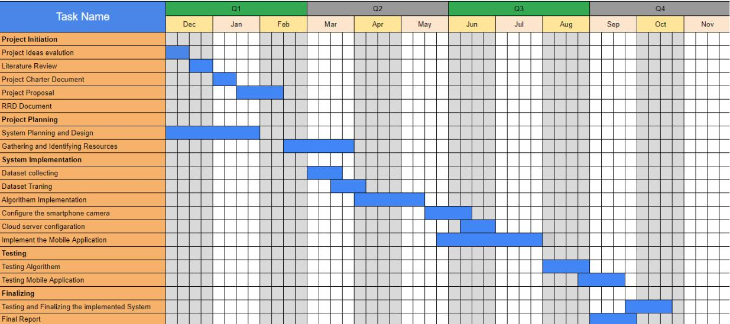

# Budget

|  |  |
| --- | --- |
| **Resources** | **Price LKR** |
|  |  |
| Educational survey cost (online payments) | 25000 |
|  |  |
| Travelling cost | 10000 |
|  |  |
| Internet | 5000 |
|  |  |
| Stationery | 5000 |
|  |  |
| Documentation and printing cost | 5000 |
|  |  |
| Total | 50000 |
|  |  |

Table 5.0: Budget

# References

|  |  |
| --- | --- |
| [1] | Statista, "MHealth app category global market potential 2016," 2016. [Online]. Available: <https://www.statista.com/statistics/625181/mobile-health-app-category-market-potential-worldwide/>. |
| [2] | "knoema.com," [Online]. Available: https://knoema.com/atlas/Sri-Lanka/Population-aged-65-years-and-above#:~:text=In%202022%2C%20population%20aged%2065,average%20annual%20rate%20of%202.05%25.. [Accessed September 2023]. |
| [3] | Wan-Young Chung and Chiew-Lian Yau, "Wireless Mobile Application for Healthcare System," *IEEE,* vol. 802.15.4, 2007. |
| [4] | Baya Maryem, Elmadani Hakima, Yazghich Ikram and Berraho Mohamed, "Diabetic patients and physicians’ acceptability of a mobile health application for Diabetes monitoring in Fez region (Morocco)," in *IEEE*, Meknes, Morocco, 2020. |
| [5] | Georgios C. Lamprinakos, Aziz S. Mousas, Andreas P. Kapsalis, Dimitra I. Kaklamani, Iakovos S. Venieris, Anastasis D. Boufis, Panagiotis D. Karmiris and Spyros G. Mantzouratos, "Using FHIR to develop a healthcare mobile application," in *IEEE*, Athens, Greece, 2014. |
| [6] | Krisana Boonphan, Pichitpong Soontornpipit, Chukiat Viwatwongkasam, Jutatrip Sillabutra, Pratana Sativipawee and Pattarakun Pramnoi, "Health Monitoring Application of Obese Children in Perspective for Guardian in Thailand," in *IEEE*, Krabi, Thailand, 2018. |
| [7] | Haoran Wang, Jing Shen, Ran Zhang, Haoen He, Yuying Song and Zhuo Shi, "A smart health data acquisition mobile application based on heart rate and blood oxygen module," in *IEEE*, Sanya, China, 2021. |
| [8] | ".wikipedia.org," [Online]. Available: https://en.wikipedia.org/wiki/Python_(programming_language). |
| [9] | "developer.android.com," [Online]. Available: https://developer.android.com/codelabs/build-your-first-android-app#0. [Accessed September 2023]. |
| [10] | "www.tensorflow.org," [Online]. Available: https://www.tensorflow.org/. [Accessed September 2023]. |
| [11] | "scikit-learn.org," [Online]. Available: https://scikit-learn.org/. [Accessed september 2023]. |
| [12] | "en.wikipedia.org," [Online]. Available: https://en.wikipedia.org/wiki/Flask_(web_framework). [Accessed september 2023]. |
| [13] | "en.wikipedia.org," [Online]. Available: https://en.wikipedia.org/wiki/MongoDB. [Accessed september 2023]. |
|  |  |
|  |  |
|  | Appendices |

